MakeFile Tutorial

Submitted By:
Uditi Arora
(2016UCP1415)

Make Utility and Makefile
The make utility is a software tool for managing and maintaining computer programs consisting many component files. The make utility automatically determines which pieces of a large program need to be recompiled, and issues commands to recompile them.
Make reads its instruction from Makefile (called the descriptor file) by default.
Makefile sets a set of rules to determine which parts of a program need to be recompile, and issues command to recompile them.
Makefile is a way of automating software building procedure and other complex tasks with dependencies.
Makefile contains: dependency rules, macros and suffix(or implicit) rules.
Compiling your source code files can be tedious, especially when you want to include several source files and have to type the compiling command every time you want to do it. Makefiles are special format files that together with the make utility will help you to automatically build and manage your projects.

The make utility
To invoke make, simply type:
make
This program will look for a file named Makefile in your directory and execute it.
If you have several makefiles, then you can execute them with the command:
make -f MyMakefile
There are several other switches to the make utility. For more info, man make .

The basic Makefile
The trivial way to compile the files and obtain an executable, is by running the command:
g++ main.cpp hello.cpp factorial.cpp -o hello
To automatically execute this command, you can create a simple Makefile with these contents:
all:
g++ main.cpp hello.cpp factorial.cpp -o hello
On this first example we see that our target is called all. This is the default target for makefiles. The make utility will execute this target if no other one is specified. We also see that there are no dependencies for target all, so make will execute the specified system command(s).

Using Dependencies
For larger projects, it can be helpful to use different targets. This is because if you modify a single file in your project, you don't have to recompile everything, only what you modified. To accomplish this, it requires breaking the build process into two steps:
a. Compilation of source code files into an object file.
b. Linking the object files into an executable.
Here is an example:
all: hello
hello: main.o factorial.o hello.o
g++ main.o factorial.o hello.o -o hello
main.o: main.cpp
g++ -c main.cpp
factorial.o: factorial.cpp
g++ -c factorial.cpp
hello.o: hello.cpp
g++ -c hello.cpp
clean:
rm -rf *.o hello
Now we see that the target all has only dependencies, but no system commands. In order for make to execute correctly, it has to meet all the dependencies of the called target (in this case all).
Each of the dependencies are searched through all the targets available and executed if found.
In this example we see a target called clean. It is useful to have such target if you want to have a fast way to get rid of all the object files and executables.

Dependency Rules

A rule consists of three parts, one or more targets, zero or more dependencies, and zero or more
commands in the form:
target: dependencies
<tab> commands to make target
• <tab> character MUST NOT be replaced be spaces.
• A “target” is usually the name of a file(e.g. executable or object files). It can also be the name of an action (e.g. clean)
• “dependencies” are files that are used as input to create the target.
• Each “command” in a rule is interpreted by a shell to be executed.
• By default, make uses /bin/sh shell.
• Typing “make target” will:
1.Make sure all the dependencies are up to date
2.If target is older than any dependency, recreate it using the specified commands.
• By default, typing “make” creates first target in Makefile.
• Since prog depends on main.o factorial.o hello.o, all of object files must exist and be up-to-date. make will check for them and recreating them if necessary
• Phony targets
– A phony target is one that isn't really the name of a file. It will only
have a list of commands and no dependencies.
E.g. clean:
rm -rf *.o

Using Variables
You can also use variables when writing Makefiles. It comes in handy in situations where you want to change the compiler, or the compiler options.
CC=g++
CFLAGS=-c -Wall
all: hello
hello: main.o factorial.o hello.o
$(CC) main.o factorial.o hello.o -o hello
main.o: main.cpp
$(CC) $(CFLAGS) main.cpp
factorial.o: factorial.cpp
$(CC) $(CFLAGS) factorial.cpp
hello.o: hello.cpp
$(CC) $(CFLAGS) hello.cpp
clean:
rm -rf *.o hello
As you can see, variables can be very useful sometimes. To use them, just assign a value to a variable before you start to write your targets. After that, you can just use them with the dereference operator $(VAR).
Command Line Approach to Compile

Codes
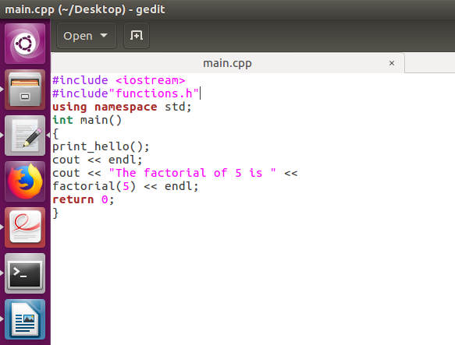

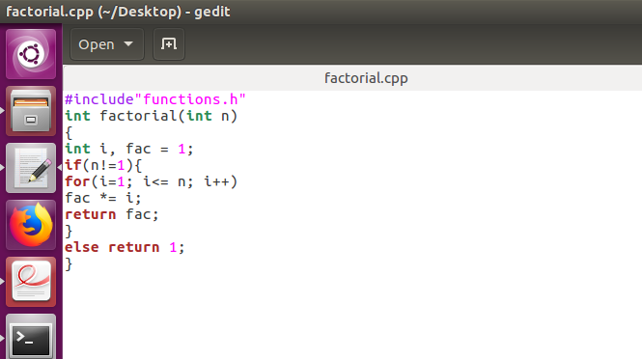

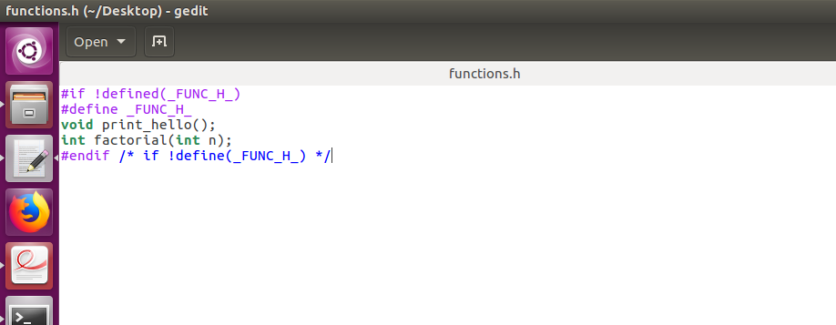

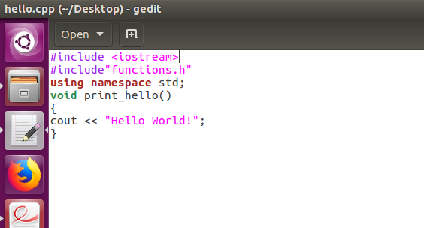

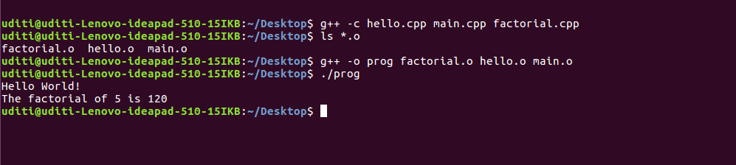

Example of a MakeFile

# This is a comment line
CC=g++
# CFLAGS will be the options passed to the compiler.
CFLAGS= -c -Wall
all: prog
prog: main.o factorial.o hello.o
$(CC) main.o factorial.o hello.o -o prog
main.o: main.cpp
$(CC) $(CFLAGS) main.cpp
factorial.o: factorial.cpp
$(CC) $(CFLAGS) factorial.cpp
hello.o: hello.cpp
$(CC) $(CFLAGS) hello.cpp
clean:
rm -rf *.o

This is for the example taken and executed above.

How Does Make Work?
• The make utility compares the modification time of the target file with the modification times of
the dependency files. Any dependency file that has a more recent modification time than its
target file forces the target file to be recreated.
• By default, the first target file is the one that is built. Other targets are checked only if they are
dependencies for the first target.
• Except for the first target, the order of the targets does not matter. The make utility will build them
in the order required.

